**IT2120 – Probability and Statistics**

**Lab Sheet 06**

**IT24102701**

**Abayawardena W.A.A.U**

**Exercise 01**

1. What is the distribution of X?

**Binomial Distribution with n = 50, p = 0.85**

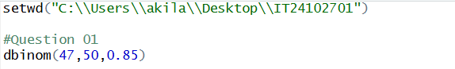

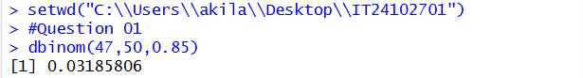

**Exercise 02**

1. What is the random variable (X) for the problem?

**Number of calls that center receives within a given hour**

1. What is the distribution of X?

**Poisson Distribution with lambda = 12**

1. What is the probability that exactly 15 calls are received in an hour

